



**Real Time Communication System Powered by AI for**

**Specially Abled**

**TEAM ID: PNT2022TMID22447**

**MENTOR: Mrs. P. Sharmila**

**INDUSTRY MENTOR: Divya**

**TEAM MEMBERS:**

* **DEVADHARSHINI M 113119UG04022**
* **DILSHAD BANU S 113119UG04024**
* **KAVITHA M 113119UG04045**
* **LUCKSHITHA V S(TEAM LEADER) 113119UG04056**

**Project Report Format**

1. **INTRODUCTION** 
   1. Project Overview
   2. Purpose
2. **LITERATURE SURVEY**
   1. Existing problem
   2. References
   3. Problem Statement Definition
3. **IDEATION & PROPOSED SOLUTION**
   1. Empathy Map Canvas
   2. Ideation & Brainstorming
   3. Proposed Solution
   4. Problem Solution fit
4. **REQUIREMENT ANALYSIS**
   1. Functional requirement
   2. Non-Functional requirements
5. **PROJECT DESIGN**
   1. Data Flow Diagrams
   2. Solution & Technical Architecture
   3. User Stories
6. **PROJECT PLANNING & SCHEDULING**
   1. Sprint Planning & Estimation
   2. Sprint Delivery Schedule
   3. Reports from JIRA
7. **CODING & SOLUTIONING (Explain the features added in the project along with code)**
   1. Feature 1
   2. Feature 2
   3. Database Schema (if Applicable)
8. **TESTING** 
   1. Test Cases
   2. User Acceptance Testing
9. **RESULTS**
   1. Performance Metrics
10. **ADVANTAGES & DISADVANTAGES**
11. **CONCLUSION**
12. **FUTURE SCOPE**
13. **APPENDIX**

Source Code

Git-Hub & Project Demo Link

**1. INTRODUCTION:**

Real-Time Communication System Powered By AI For Specially Abled In our society, we have people with disabilities. The technology is developing day by day but no significant developments are undertaken for the betterment of these people. Communications between deaf-mute and a normal person has always been a challenging task. It is very difficult for mute people to convey their message to normal people. Since normal people are not trained on hand sign language. In emergency times conveying their message is very difficult. The human hand has remained a popular choice to convey information in situations where other forms like speech cannot be used. Voice Conversion System with Hand Gesture Recognition and translation will be very useful to have a proper conversation between a normal person and an impaired person in any language.RTC helps you develop multi-device, real-time applications for scenarios such as online education, video conferencing, interactive entertainment, and audio and video social networking.RTC relies on the core technologies of ApsaraVideo, such as intelligent noise reduction algorithms, Narrowband HD™, and real-time transmission algorithms, to deliver high-quality communication services in noisy environments with unstable network connections and a packet loss rate of up to 80%.

* 1. **PROJECT OVERVIEW:**

The project aims to develop a system that converts the sign language into a human hearing voice in the desired language to convey a message to normal people, as well as convert speech into understandable sign language for the deaf and dumb. We are making use of a convolution neural network to create a model that is trained on different hand gestures. An app is built which uses this model. This app enables deaf and dumb people to convey their information using signs which get converted to human-understandable language and speech is given as output. Smartphone are a powerful tool that help users with a visual impairment. Indeed, many apps enable them to remain autonomous. For example, thanks to Seeing AI, visually impaired people can easily read their mail by placing documents under the smart-phone camera. AI technology can apply to any type of disability profile. For instance, people with reduced mobility can control everything at home just by using their voice with a virtual personal assistant such as Amazon Alexa.

* 1. **PURPOSE:**

The primary goal of all disability support services should be to help handicapped people achieve the greatest level of independence that they can so they can contribute to society on their own. To help them to attain overall development .To impart quality education & help them to avail benefits of various govt schemes .To make them self- reliant.

2**. LITERATURE SURVEY:**

The section below runs through the cross-sectionof research work carried out around ‘LearningDisability’ specific to India, encompassing differentchallenges, status of current work, with respect totechnology, tools and facilities and Government aidsand policies.

* **Survey on sign language recognition in context of vision-based and deep learning:**

A sign language recognition system has been developed from classifying only static signs and alphabets to a system that can effectively apprehend dynamic actions that come in continuous sequences of images. Researchers are currently paying more attention to making a large vocabulary for sign language recognition systems. Dataset

availability and improvements in computing speed provide access to more training for given samples. The classification technique for identifying sign language also varies among researchers. Using their ideas and limitations for the Sign Language Recognition System, the comparison of one method to another method is still subjective. Deep

learning-based approaches like CNN, RNN, LSTM, and Bi-Directional LSTM Models provide good recognition accuracy in the sequence of images and video streams.

* **Artificial Intelligence enabled virtual sixth sense application for the disabled:**

The current implementation deals with object recognition and text to speech and a speech to text converter by utilizing the Web Speech API (Application Program Interface) for the website and text to speech and speech to text library for the mobile platform. The object recognition wouldn't fetch enough use out of a website. Hence, it has

been implemented on the mobile app utilizing the Firebase ML toolkit and different pre-trained models, which are both available offline as well as online. The major contribution of the work is an innovative approach for text to speech is implemented to provide a faster and convenient approach for mute to communicate through SAM (Speech Assisted for Mute).

* **Design of a Communication System using Sign Language aid for Differently Abled Peoples:**

To design a human computer interface system that can accurately identify the language of the deaf and

dumb. With the use of image processing and artificial intelligence, many techniques and algorithms have been developed in this area. Each character speech recognition system is trained to recognize the characters and convert them into the required pattern.

* **Sign Language Recognition using Neutral Network:**

The system presents a performance pretty good to identify the static images of the sign alphabetic language. In this

work, the developed hardware architecture is used as image recognizing system but it is not only limited to this application, it means, the design can be employed to process other type of signs. As future work, it is planned to add to the system a learning process for dynamic signs, as well as to prove the existing system with images taken in

different position.

* **Real-Time Sign Language Detection using TensorFlow, OpenCV and Python:**

The system accepts a hand gesture as input and displays

the identified character on the monitor screen in real time. This project falls under the category of human-computer interaction (HCI) and tries to recognise multiple alphabets (a-z), digits (0-9) and several typical ISL hand gestures. To apply Transfer learning to the problem, we used a Pre-Trained SSD Mobile net V2 architecture trained on our own dataset. The main goal of this research is to create a computer-based intelligent system that will allow deaf persons to interact effectively with others by utilising hand gestures based on technologies tensor flow, object detection, open cv, labelling.

* **Deep sign: Sign Language Detection and Recognition Using Deep Learning Article:**

Sign Language recognition using LSTM and GRU on an IISL2020 dataset of different hand gesture the developed models work in terms of isolated signs; this approach could be utilized for interpreting continuous sign language that leads to syntax generation, especially in the context of ISL. The use of vision transformers can lead to more accurate results than those of feedback-based learning models.

**2.1 EXISTING PROBLEM:**

A large number of disabilities are preventable, including those arising from medical issues during birth, maternal conditions, malnutrition, as well as accidents and injuries. However, the health sector especially in rural India has failed to react proactively to disability .Further there are lack of affordable access to proper health care, aids and appliances. Healthcare facilities and poorly trained health-workers in rehabilitation centres is another concern. Factors in a person’s environment that, through their absence or presence, limit functioning and create disability. These include aspects such as:

A physical environment that is not accessible, lack of relevant assistive technology (assistive, adaptive, and rehabilitative devices),negative attitudes of people towards disability, services, systems and policies that are either nonexistent or that hinder the involvement of all people with a health condition in all areas of life.”

**2.2 REFERENCES:**

**Paper 1: A Communication System For Deaf and Dumb People**

**Publication Year: 2015**

**Author: Shraddha R. Ghorpade**

**Journal Name: International Journal Of Science and Research**

Humans know each other by conveying their ideas, thoughts, and experiences to the people around them. There are numerous ways to achieve this and the best one among the rest is the gift of “Speech”. Through speech everyonecan very convincingly transfer their thoughts and understand each other. It will be injustice if we ignore those who are deprived of this invaluable gift; the deaf and dumb people. The only means of communication available to the deaf and dumb people is the use of “Sign Language”. Very few people who are not themselves deaf and dumb ever learn to Sign language. These limitation increases the isolation of deaf and dumb people from the common society. Technology is one way to remove this hindrance and benefit these people.

**Paper 2: A Communication Between Deaf and Dumb People and Normal People: Chat Assist**

**Publication Year: 2017**

**Author: L. Jayatilake , C. Darshana , G. Indrajith , A. Madhuwantha and N.Ellepola**

**Journal Name: International Journel Of Science and Research Publications**

Sign languages are different according to the country and nations. The system has developed for Sinhala sign language. The Sinhala Sign Language contains different set of signs and those signs were studied by group member. Voice has translated to the text and then translate to the sign language is another component of this project. That component has added for make more efficient real time face to face chatting feature to this system. The system has focused on voice and text and it was needed to clarify whether voice to sign translation consumes more time. If it does not consume more time, then we needed to research about accuracy of translated sentences and utterances. The main research problem was lacking of any communication media between hard of hearing people and normal people.Themain objective of this application was, reduce the communication gap between normal people and deaf-dumb people by giving some help to deaf-dumb people to do their works at their convenient and also allowing them to chat with ease by using this tool.

**Paper 3: A Communication Assistant for Deaf and Dumb People**

**Publication Year: 2019**

**Author: Rajyashree, O. Deepak, Naresh Rengaswamy, K. S. Vishal**

**Journal Name: International Journel Of Science and Research Publications**

Having difficulties like being visually impaired, hard of hearing, dumb are a greater amount of concern. Science and innovation have influenced people to turn out to be dependent on solace yet there exists an underprivileged gathering of individuals who are battling for finding a creative way that can make the procedure of communication simpler for them. As indicated by the World Health Organization, around 285 million individuals on the planet are visually impaired, 300 million are hard of hearing and 1 million are mute. In everyday life communication is a serious issue for the deaf, dumb and blind people. The gestures created by the disabled person will be sent to normal person’s device and will also be displayed on LCD. There are many individuals who are completely deaf and blind. For such individuals, their primary means of communication have to do with Braille or they use some other system such as tactile sign language, where they are actually in physical contact with the person they are communicating with.

**Paper 4: A Communication System for Deaf and Dumb**

**Publication Year: 2016**

**Author: Anchal Sood, Anju Mishra**

**Journal Name: IEEE**

According to a survey conducted by disabled welfare department, about eight lakh people in India are deaf and dumb. The issues confronted by the deaf and dumb individuals in India can be comprehensively grouped into classes like social connection, communication, behavioural issues, psychological well-being, and safety concerns. Their issues have been intensified by the absence of a legitimate gesture based communication translator in India. They can, however write and communicate easily.

**Paper 5:A Novel Approach For Communication Among Deaf and Dumb People**

**Publication Year: 2018**

**Author: Sharad Agarwal, Falgun Patel, Prakhar Chaturvedi**

**Journal Name: International Journal Of Pure and Applied Mathematics**

Science and Technology have made Human life addictive to comfort but still there exists an underprivileged group of people who are fighting for finding an innovative way that can make the process of communication easier for them. According to the World Health Organization, about 285 million people in the world are blind, 300 million are deaf and 1 million are dumb. In this project, we are going to propose a new system-prototype called the SHARO] AN BRIDGE in an effort to bridge the gap in the process of communication between the Blind, Deaf and Dumb people. The SHARO]AN BRIDGE will make use of the Wearable Technology, Texas Instrumentation Circuitry and Arduino Circuit Boards to provide a means of communication to differently-abled people having one or all of the above mention disabilities. It is assumed that a person who isdeaf is also dumb but vice versa is not true.

**2.3 PROBLEM STATEMENT DEFINITION:**

Persons with disabilities include those who have long-term physical, mental, intellectual or sensory impairments which in interaction with various barriers may hinder their full and effective participation in society on an equal basis with others.

A disability is any condition of the body or mind (impairment) that makes it more difficult for the person with the condition to do certain activities (activity limitation) and interact with the world around them (participation restrictions.

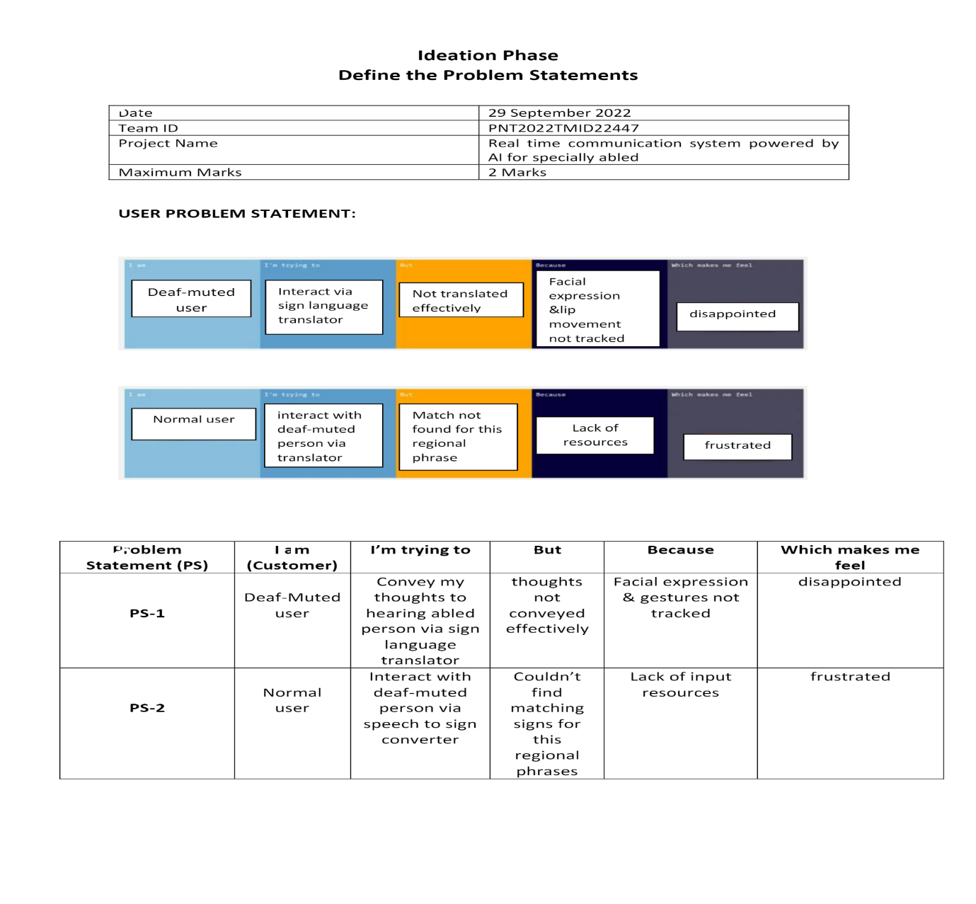

**3. IDEATION AND PROPOSED SOLUTION:**

**3.1 EMPATHY MAP CANVAS:**

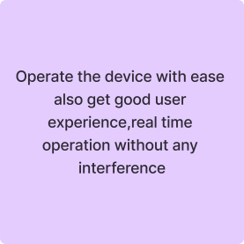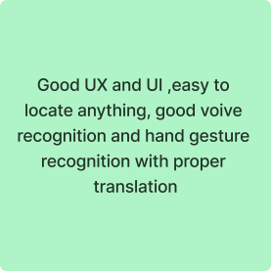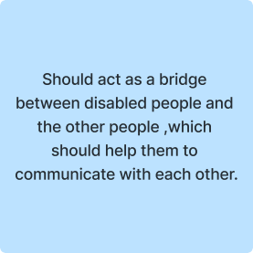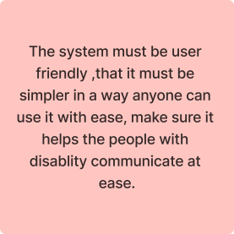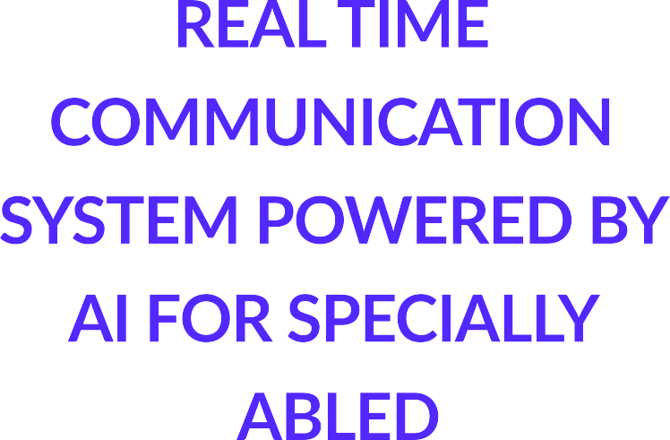

**GAIN PAIN**

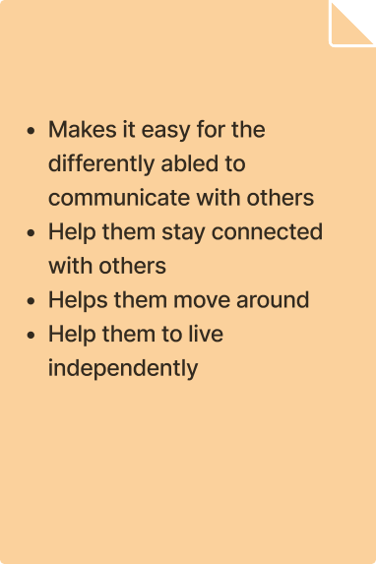

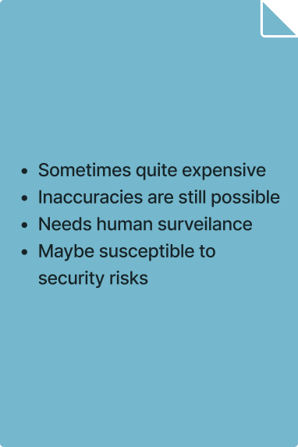

An empathy map canvas is a more depth version of the original empathy map,which helps identify and describe the user’s needs and pain points. And this isvaluable information for improving the user experience.

Teams rely on user insights to map out what is important to their target audice, what influences them, and how they present themselves. This information is used to create personas that help teams visualize users and empathize withindividuals, rather than just as a vague marketing demographic or account.

**3.2 IDEATION AND BRAINSTORMING:**

**INTRODUCTION:**

Communication should be universal without any barriers or limitations. Communications between deaf-mute and a normal person has always been a challenging task. It is very difficult for mute people to convey their message to normal people. Since normal people are not trained on hand sign language. In emergency times conveying their message is very difficult. This system establishes a method for providing equality, turning the disabilities of the hearing or speech impaired individuals to abilities, creating a base where both disabled and the able can communicate without any barrier. Our objective is to blend deaf and dumb within society and make them able to interact efficiently. Our idea is to create sign assistance, like many applications which is using voice assistance such as Siri on iOS and Cortana on windows. There is need to develop a system that will create an interactive platform where the sign language can be translated to voice output and writing, and voice and writing input can also be converted to sign language.

**GOALS:**

Artificial intelligence directly impacts disabled people’s lives in three ways-

* enabling communication
* enhancing accessibility
* providing the advantage to live independently

**TECHNOLOGY FOR DISABLED COMMUNICATION:**

* Technology has helped people a lot and resulted in much advancement in the world. Now people can talk with others far away using a phone, read hundreds of books in one kindle, find the directions to their destination on online maps and so much more. Since technology is a tool for helping people, it stands to reason that disabled people are not neglected and technology also helps them in leading a better life.
* ‌A sophisticated device called Orcam My Eye 2 is capable of reading books, recognizing faces, and even recognising the value of money and some other common items. This advanced device uses technologies such as AI, OCR (optical character recognition), and machine learning.
* Extended Reality (XR) is an emerging umbrella term for all immersive technologies like augmented reality (AR), Virtual Reality (VR), and mixed reality (MR).
* By availing of XR, people with motion disabilities can carry out assignments and work tasks remotely.
* ‌Educational Testing Service (ETS) used technologies from Amazon to replace some human recorded audio with synthesized speech for some supplemental test content.
* ‌ETS improved the user experience for students with disabilities by reducing the turnaround time for producing alternate format materials and providing a more natural and clear text-to-speech voice for these students.

**10 Tech Devices that help People with Disabilities**

### **1. Liftware 6. Ava**

### **2. Dot 7. Voiceitt**

### **3. Finger Reader 8. Be My Eyes**

### **4. Sesame Phone 9. AXS Map**

### **5. Uni 10. Assist-Mi**

**For blind or visually impaired people:**

* Voice Over: a screen reader directly integrated on i-Phones. Although its main use is to enunciate any email or textual message, Voice Over also uses AI to describe apps icons, the battery level and even in part images.
* Talk Back: the equal of Voice Over for Android smart phones. It enables users to fully use their smart phones.
* Cortana: a virtual assistant created by Microsoft and implemented on Windows. It helps blind or visually impaired users to navigate on their computer using simply their voice. In a sense, it’s similar to Siri.
* Google Assistant: an app activated by voice control. Users can easily set up an alarm or manage their schedule, the same way as Siri.

**For deaf or hard of hearing people:**

* Ava: an instant transcription app that uses AI to instantly transcribe the conversation of a group of people. Its algorithm adds punctuation, the name of the person who is talking and the necessary vocabulary from the user’s dictionary. An easy way for people with a hearing impairment to be included and to follow a conversation with several people without lip-reading.
* Roger Voice: a French instant transcription app for group conversations available in 90 languages. It works the same way as Ava.

**ENHANCING ACCESSIBILITY:**

* A facial recognition with an AI software to replace CAPTCHAs that can be difficult to find for people with a visual impairment,
* A keyboard navigation optimization via the “Tab” button for people with physical disabilities,
* A voice-recognition or a speech-recognition technology like Google’s Project Euphonia for people with speech impairments to use the Internet thanks to sounds and gestures,
* Audio descriptions content for people with a visual impairment,
* Captions and translations of online videos for people with a hearing impairment like Microsoft Translator,
* Readjustments of graphic elements such as fonts, colors and spacing for people with a visual impairment,

A built-in library of idioms, slang and phrases that are unusually used for people with a mental impairment

# **The project aims to develop a system that converts the sign language into a human hearing voice in the desired language to convey a message to normal people, as well as convert speech into understandable sign language for the deaf and dumb and improve their accessibility of communication and make them live independently as normal people.**

**3.3 PROPOSED SOLUTION:**

**Proposed Solution:**

Project team shall fill the following information in proposed solution

|  |  |  |
| --- | --- | --- |
| **S.No** | **Parameter** | **Description** |
| 1. | Problem Statement (Problem to be  solved | • Everyone is not convenient with  language used in the application  • Some people cannot understand  English we can convert into their  convenient language  • They are facing difficulties in  understanding the language used in  the system |
| 2. | Idea / Solution description | • Even sign language can also be  translated to text message in our  application using CNN.  • Text to sign language convertor uses  Stanford Parser text processing and  JASigning for the signing avatar  • Can change the language using  google language translator tool so  that people can use the application  based on their specialised language  • Producing a model which can  recognize Finger-spelling based hand  gestures in order to form a complete  word by combining each gesture  • By using this application both  specially abled and normal people can  translate their messages to others  easily |
| 3. | Novelty / Uniqueness | • Convenient language can be changed  using the google language translator  tool  • Normal text can also be translated  into sign language |
| 4. | Social Impact / Customer  Satisfaction | • The Main aim of the project is to build  an application that helps the specially  abled people to communicate with  others easily  • The deaf people can easily  translate their sign language into a  human hearing voice  • The normal people can also easily  translate their voice into a sign  language using this application |
| 5. | Business Model (Revenue Model) | • We can generate revenue by offering  subscription-based applications to the  people  • Users who have got subscription can  change the language accordingly |
| 6. | Scalability of the Solution | • Even if the number of users increase  the system will perform well  • Need to pay attention to the  application and to be responsive to  the changes as fast as possible |

**3.4 PROBLEM SOLUTION FIT:**

It fit is a term used to describe the point validating that the baseproblem resulting in a business idea really exists and the proposed solution actuallysolves that problem.

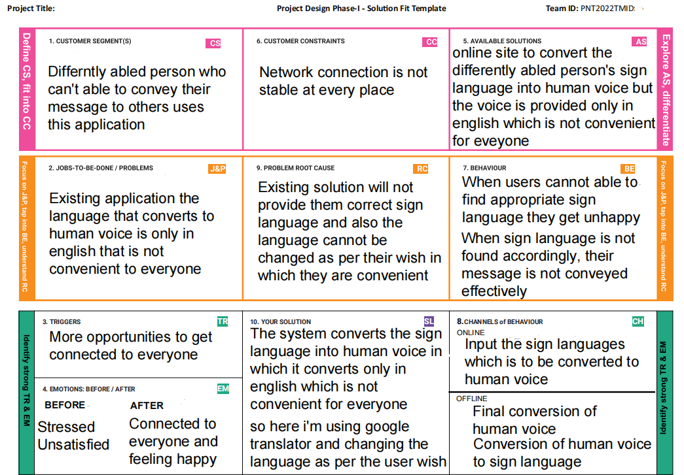

**4. REQUIREMENT ANALYSIS:**

**4.1 FUNCTIONAL REQUIREMENT:**

**PROJECT DESIGN PHASE-II**

**SOLUTION REQUIREMENT (FUNCTIONAL AND NON FUNCTIONAL)**

A functional requirement document helps you to define the functionality of a system one of its subsystems.

|  |  |  |
| --- | --- | --- |
|  | **Functional Requirement (Epic)** | **Sub Requirement (Story / Sub-Task)** |
| FR-1 | User Registration | **LOW VISION:**  As a user who has trouble reading due to low vision, I want to be able to make the text larger on the screen so that I can read it.  **Registration through Gmail** |
| FR-2 | User Confirmation | **IMPAIRED USER:**  As a user who is hearing -impaired, I want a turn on video captions so that I can understand what is being said in videos.  **Confirmation via Email** |
| FR-3 | User Registration | **COLOR BLINDNESS**:  As a user who is color blind, I want to links to be distinguishable on the page so that I can find the links and navigate the site.  **Registration through Gmail** |

Functional requirement along with requirement analysis help identify missing requirements. They clearly define the expected system service and behaviour.

**4.2 NON FUNCTIONAL REQUIREMENT:**

Following are the non-functional requirements of the proposed solution.

|  |  |  |
| --- | --- | --- |
| **FR No.** | **Non-Functional Requirement** | **Description** |
| NFR-1 | **Usability** | * Visual and Audio Help * Text size scaling * Reverse contrast |
| NFR-2 | **Security** | Important information:   * Walking in single file or in narrow space. * Steps, Stairs and Slope. * Kerbs and Roads |
| NFR-3 | **Reliability** | To determine reliability measures are:   * Test-Retest Repeatability * Individual Repeatability |
| NFR-4 | **Performance** | To determine predictors of success in reading with low vision aids, in terms of reading acuity, optimum acuity reserve, and maximum reading speed , for observers with low vision for various causes. |
| NFR-5 | **Availability** | Lack of adequate low vision services and barriers to their provision and uptake impact negatively on efforts to prevent visual impairment and blindness. |
| NFR-6 | **Scalability** | There is a large selection of device to help people with low vision .Some are “Optical”, glass lenses such as magnifying glasses and telescopes. |

Non- functional requirements are the set of specifications that describe the system’s operation capabilities and constraints and attempt to improve its functionality. These are basically the requirements that outline how well it will operate including things like speed, security, reliability, data integrity etc.

**5. PROJECT DESIGN:**

**5.1 DATA FLOW DIAGRAMS:**

A Data Flow Diagram (DFD) is a traditional visual representation of the information flows within a system. A neat and clear DFD can depict the right amount of the system requirement graphically. It shows how data enters and leaves the system, what changes the information and where data is stored.

DATA FLOW DIAGRAM

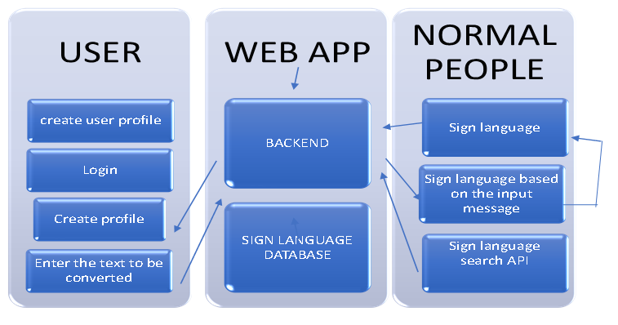

**5.2 SOLUTION AND TECHNICAL ARCHITECTURE :**

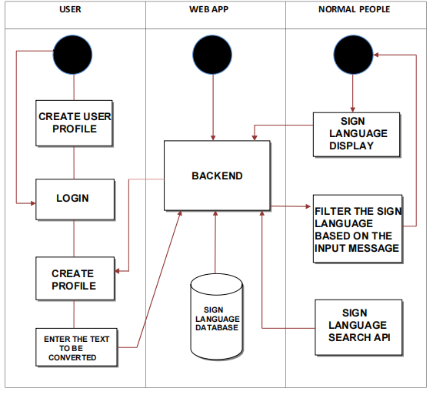

|  |  |  |  |  |  |
| --- | --- | --- | --- | --- | --- |
| **User Type** | **User Story Number** | **User Story / Task** | **Acceptance criteria** | **Priority** | **Release** |
| Customer  (Low vision) | USN-1 | As a user, who has trouble reading due to low vision, I want to be able to make the text larger on the screen so that I can read it. | I can access my account / dashboard | High | Sprint-1 |
| Customer  (Color blindness) | USN-2 | As a user, who is colorblind ,I want to have access to information conveyed in color so that, I do not miss anything and I understand the content. | I can receive confirmation email & click confirm | High | Sprint-1 |
| Customer  (Impaired user) | USN-3 | As a user, who is hearing-impaired, I want a transcript of the spoken audio so that I can have access to all information provided in audio clips | I can register & access the dashboard with face-book Login | Low | Sprint-2 |

**5.3 USER STORIES:**

User stories:

**6. PROJECT PLANNING AND SCHEDULING:**

**6.1 SPRINT PLANNING AND ESTIMATION:**

|  |  |  |  |  |  |  |
| --- | --- | --- | --- | --- | --- | --- |
| **Sprint** | **Functional**  **Requirement (Epic)** | **User Story**  **Number** | **User Story / Task** | **Story Points** | **Priority** | **Team Members** |
| Sprint-1 | Data Collection | USN-1 | Collect required Dataset | 8 | Low | Luckshitha VS |
| Sprint-1 | Image Pre- processing | USN-2 | Pre-process the data by importing and configuring libraries, applying functionalities to train and test data | 12 | High | Luckshitha VS |
| Sprint-2 | Model Building | USN-3 | Import the required model building libraries, initialize the model by adding layers | 7 | Low | Kavitha M |
| Sprint-2 | Layer inclusion | USN-4 | Adding convolution, pooling, flatten and dense layers, compile, fit and save model. | 10 | Medium | Kavitha M |
| Sprint-3 | Test the model | USN-5 | Import packages and load the saved model for testing saved model, pre-process, predict | 10 | High | Devadharshini M |
| Sprint-3 | Application Building | USN-6 | Build flask app and HTML page by loading required packages and initialize it to meet model requirements for predictions | 12 | High | Devadharshini M |
| Sprint-4 | Train CNN model On IBM | USN-7 | Register and create the required resources for CNN deployment | 9 | Medium | Dilshad Banu S |
| Sprint-4 | Implementation and checking results | USN-8 | train, store, integrate with flask and download model to test locally for getting final outputs | 11 | High | Dilshad Banu S |

|  |  |  |  |  |  |  |
| --- | --- | --- | --- | --- | --- | --- |
| **Sprint** | **Total Story Points** | **Duration** | **Sprint Start Date** | **Sprint End Date (Planned)** | **Story Points Completed (as on**  **Planned End Date)** | **Sprint Release Date (Actual)** |
| Sprint-1 | 20 | 6 Days | 24 Oct 2022 | 29 Oct 2022 | 20 | 29 Oct 2022 |
| Sprint-2 | 20 | 6 Days | 31 Oct 2022 | 05 Nov 2022 | 17 | 05 Nov 2022 |
| Sprint-3 | 20 | 6 Days | 07 Nov 2022 | 12 Nov 2022 | 18 | 12 Nov 2022 |
| Sprint-4 | 20 | 6 Days | 14 Nov 2022 | 19 Nov 2022 | 17 | 19 Nov 2022 |

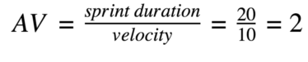

**6.3 REPORTS FROM JIRA:**

Jira Software is part of a family of products designed to help teams of all types manage work. Originally, Jira was designed as a bug and issue tracker. But today, Jira has evolved into a powerful work management tool for all kinds of use cases, from requirements and test case management to agile software development.

**SPRINT 1:**

**DATA COLLECTION:**

|  |  |
| --- | --- |
| **[RTCSPBAFSA-1]**[Data Collection](https://devadharshinimohan.atlassian.net/browse/RTCSPBAFSA-1)Created: 06/Nov/22  Updated: 09/Nov/22  Resolved: 09/Nov/22 | |
| **Status:** | Done |
| **Project:** | [Real Time Communication System Powered By AI For Specially Abled](https://devadharshinimohan.atlassian.net/secure/BrowseProject.jspa?id=10001) |
| **Components:** | Dataset |
| **Affects versions:** | None |
| **Fix versions:** | None |

|  |  |  |  |
| --- | --- | --- | --- |
| **Type:** | Task | **Priority:** | Medium |
| **Reporter:** | [Devadharshini Mohan](https://devadharshinimohan.atlassian.net/secure/ViewProfile.jspa?accountId=63678ad0d7c060fdaa5adeb8) | **Assignee:** | [LUCKSHITHA.V.S](https://devadharshinimohan.atlassian.net/secure/ViewProfile.jspa?accountId=63678d45d60bd2b365f8330e) |
| **Resolution:** | Done | **Votes:** | 03 |
| **Labels:** | None | | |
| **Remaining Estimate:** | 3 days | | |
| **Time Spent:** | 3 days | | |
| **Original estimate:** | 6 days | | |

|  |  |
| --- | --- |
| **Rank:** | 1 |
| **Sprint:** | RTCSPBAF Sprint 1 |

|  |  |
| --- | --- |
| **Description** |  |

|  |
| --- |
| Collect required Dataset |

**IMAGE PRE-PROCESSING :**

|  |  |
| --- | --- |
| **[RTCSPBAFSA-2]**[Image pre-processing](https://devadharshinimohan.atlassian.net/browse/RTCSPBAFSA-2)Created: 06/Nov/22  Updated: 09/Nov/22  Resolved: 06/Nov/22 | |
| **Status:** | Done |
| **Project:** | [Real Time Communication System Powered By AI For Specially Abled](https://devadharshinimohan.atlassian.net/secure/BrowseProject.jspa?id=10001) |
| **Components:** | Google Colab |
| **Affects versions:** | None |
| **Fix versions:** | None |

|  |  |  |  |
| --- | --- | --- | --- |
| **Type:** | Task | **Priority:** | Medium |
| **Reporter:** | [Devadharshini Mohan](https://devadharshinimohan.atlassian.net/secure/ViewProfile.jspa?accountId=63678ad0d7c060fdaa5adeb8) | **Assignee:** | [LUCKSHITHA.V.S](https://devadharshinimohan.atlassian.net/secure/ViewProfile.jspa?accountId=63678d45d60bd2b365f8330e) |
| **Resolution:** | Done | **Votes:** | 03 |
| **Labels:** | None | | |
| **Remaining Estimate:** | 0 day | | |
| **Time Spent:** | 3 days | | |
| **Original estimate:** | 6 days | | |

|  |  |
| --- | --- |
| **Rank:** | 2 |
| **Sprint:** | RTCSPBAF Sprint 1 |

|  |  |
| --- | --- |
| **Description** |  |

|  |
| --- |
| pre-process the data by importing and configuring libraries, applying functionalities to train and test data |

**SPRINT 2:**

**MODEL BUILDING :**

|  |  |
| --- | --- |
| **[RTCSPBAFSA-9]**[Model Building](https://devadharshinimohan.atlassian.net/browse/RTCSPBAFSA-9)Created: 06/Nov/22  Updated: 09/Nov/22  Resolved: 06/Nov/22 | |
| **Status:** | Done |
| **Project:** | [Real Time Communication System Powered By AI For Specially Abled](https://devadharshinimohan.atlassian.net/secure/BrowseProject.jspa?id=10001) |
| **Components:** | Google Colab |
| **Affects versions:** | None |
| **Fix versions:** | None |

|  |  |  |  |  |  |
| --- | --- | --- | --- | --- | --- |
| **Type:** | Task | | | **Priority:** | Medium |
| **Reporter:** | [Devadharshini Mohan](https://devadharshinimohan.atlassian.net/secure/ViewProfile.jspa?accountId=63678ad0d7c060fdaa5adeb8) | | | **Assignee:** | [kavitha](https://devadharshinimohan.atlassian.net/secure/ViewProfile.jspa?accountId=63678d45c383ad842145e58b) |
| **Resolution:** | Done | | | **Votes:** | 3 |
| **Labels:** | | None | | | | |
| **Remaining Estimate:** | | 3 days | | | | |
| **Time Spent:** | | 3 days | | | | |
| **Original estimate:** | | 6 days | | | | |
| **Rank:** | | | 3 | | | | |
| **Sprint:** | | | RTCSPBAF Sprint 2 | | | | |

|  |  |
| --- | --- |
| **Description** |  |

|  |
| --- |
| Import the required model building libraries, initialize the model by adding layers |

**LAYER INCLUSION :**

|  |  |
| --- | --- |
| **[RTCSPBAFSA-10]**[Layer Inclusion](https://devadharshinimohan.atlassian.net/browse/RTCSPBAFSA-10)Created: 06/Nov/22  Updated: 09/Nov/22  Resolved: 06/Nov/22 | |
| **Status:** | Done |
| **Project:** | [Real Time Communication System Powered By AI For Specially Abled](https://devadharshinimohan.atlassian.net/secure/BrowseProject.jspa?id=10001) |
| **Components:** | Google Colab |
| **Affects versions:** | None |
| **Fix versions:** | None |

|  |  |  |  |
| --- | --- | --- | --- |
| **Type:** | Task | **Priority:** | Medium |
| **Reporter:** | [Devadharshini Mohan](https://devadharshinimohan.atlassian.net/secure/ViewProfile.jspa?accountId=63678ad0d7c060fdaa5adeb8) | **Assignee:** | [kavitha](https://devadharshinimohan.atlassian.net/secure/ViewProfile.jspa?accountId=63678d45c383ad842145e58b) |
| **Resolution:** | Done | **Votes:** | 3 |
| **Labels:** | None | | |
| **Remaining Estimate:** | 0 day | | |
| **Time Spent:** | 3 days | | |
| **Original estimate:** | 3 days | | |

|  |  |
| --- | --- |
| **Rank:** | 4 |
| **Sprint:** | RTCSPBAF Sprint 2 |

|  |  |
| --- | --- |
| **Description** |  |

|  |
| --- |
| Adding convolution, pooling, flatten and dense layers, compile, fit and save models |

**SPRINT 3:**

**APPLICATION BUILDING :**

|  |  |
| --- | --- |
| **[RTCSPBAFSA-29]**[Application Building](https://devadharshinimohan.atlassian.net/browse/RTCSPBAFSA-29)Created: 09/Nov/22  Updated: 09/Nov/22  Resolved: 09/Nov/22 | |
| **Status:** | Done |
| **Project:** | [Real Time Communication System Powered By AI For Specially Abled](https://devadharshinimohan.atlassian.net/secure/BrowseProject.jspa?id=10001) |
| **Components:** | Visual Studio Code |
| **Affects versions:** | None |
| **Fix versions:** | None |

|  |  |  |  |
| --- | --- | --- | --- |
| **Type:** | Story | **Priority:** | Medium |
| **Reporter:** | [Devadharshini Mohan](https://devadharshinimohan.atlassian.net/secure/ViewProfile.jspa?accountId=63678ad0d7c060fdaa5adeb8) | **Assignee:** | [Devadharshini Mohan](https://devadharshinimohan.atlassian.net/secure/ViewProfile.jspa?accountId=63678ad0d7c060fdaa5adeb8) |
| **Resolution:** | Done | **Votes:** | 3 |
| **Labels:** | None | | |
| **Remaining Estimate:** | 3 days | | |
| **Time Spent:** | 3 days | | |
| **Original estimate:** | 6 days | | |

|  |  |
| --- | --- |
| **Rank:** | 5 |
| **Sprint:** | RTCSPBAF Sprint 3 |

**TESTING THE MODEL :**

|  |  |
| --- | --- |
| **[RTCSPBAFSA-34]**[Testing the model](https://devadharshinimohan.atlassian.net/browse/RTCSPBAFSA-34)Created: 09/Nov/22  Updated: 18/Nov/22  Resolved: 09/Nov/22 | |
| **Status:** | Done | |
| **Project:** | [Real Time Communication System Powered By AI For Specially Abled](https://devadharshinimohan.atlassian.net/secure/BrowseProject.jspa?id=10001) | |
| **Components:** |  | |
| **Affects versions:** | None | |
| **Fix versions:** | None | |

|  |  |  |  |
| --- | --- | --- | --- |
| **Type:** | Story | **Priority:** | Medium |
| **Reporter:** | [Devadharshini Mohan](https://devadharshinimohan.atlassian.net/secure/ViewProfile.jspa?accountId=63678ad0d7c060fdaa5adeb8) | **Assignee:** | [Devadharshini Mohan](https://devadharshinimohan.atlassian.net/secure/ViewProfile.jspa?accountId=63678ad0d7c060fdaa5adeb8) |
| **Resolution:** | Done | **Votes:** | 0 |
| **Labels:** | None | | |
| **Remaining Estimate:** | 0 day | | |
| **Time Spent:** | 3 days | | |
| **Original estimate:** | 6 days | | |

|  |  |  |
| --- | --- | --- |
| **Rank:** | | 6 |
| **Sprint:** | | RTCSPBAF Sprint 3 |
| **Description** |  | |

|  |
| --- |
| Testing the model which have been developed in the application building phase |

**SPRINT 4 :**

**IMPLEMENTING and VERIFYING THE OUTPUT :**

|  |  |
| --- | --- |
| **[RTCSPBAFSA-31]**[**Implementating and verifying the output**](https://devadharshinimohan.atlassian.net/browse/RTCSPBAFSA-31)Created: 09/Nov/22  Updated: 17/Nov/22  Resolved: 17/Nov/22 | |
| **Status:** | Done |
| **Project:** | [Real Time Communication System Powered By AI For Specially Abled](https://devadharshinimohan.atlassian.net/secure/BrowseProject.jspa?id=10001) |
| **Components:** | Visual Studio code |
| **Affects versions:** | None |
| **Fix versions:** | None |

|  |  |  |  |
| --- | --- | --- | --- |
| **Type:** | Story | **Priority:** | Medium |
| **Reporter:** | [Devadharshini Mohan](https://devadharshinimohan.atlassian.net/secure/ViewProfile.jspa?accountId=63678ad0d7c060fdaa5adeb8) | **Assignee:** | [Dilshad Banu S](https://devadharshinimohan.atlassian.net/secure/ViewProfile.jspa?accountId=635f4bf2c97f5473af712b05) |
| **Resolution:** | Done | **Votes:** | 3 |
| **Labels:** | None | | |
| **Remaining Estimate:** | 3 days | | |
| **Time Spent:** | 3 days | | |
| **Original estimate:** | 6 days | | |

|  |  |  |
| --- | --- | --- |
| **Rank:** | | 7 |
| **Sprint:** | | RTCSPBAF Sprint 4 |
| **Description** |  | |

|  |
| --- |
| Train, store, integrate with flask and download model to test locally for getting final outputs. |

**TRAIN CCN MODEL ON IBM :**

|  |  |
| --- | --- |
| **[RTCSPBAFSA-30]**[Train CNN model on IBM](https://devadharshinimohan.atlassian.net/browse/RTCSPBAFSA-30)Created: 09/Nov/22  Updated: 17/Nov/22  Resolved: 17/Nov/22 | |
| **Status:** | Done |
| **Project:** | [Real Time Communication System Powered By AI For Specially Abled](https://devadharshinimohan.atlassian.net/secure/BrowseProject.jspa?id=10001) |
| **Components:** | IBM Watson Studio |
| **Affects versions:** | None |
| **Fix versions:** | None |

|  |  |  |  |
| --- | --- | --- | --- |
| **Type:** | Story | **Priority:** | Medium |
| **Reporter:** | [Devadharshini Mohan](https://devadharshinimohan.atlassian.net/secure/ViewProfile.jspa?accountId=63678ad0d7c060fdaa5adeb8) | **Assignee:** | [Dilshad Banu S](https://devadharshinimohan.atlassian.net/secure/ViewProfile.jspa?accountId=635f4bf2c97f5473af712b05) |
| **Resolution:** | Done | **Votes:** | 03 |
| **Labels:** | None | | |
| **Remaining Estimate:** | 0 day | | |
| **Time Spent:** | 3 days | | |
| **Original estimate:** | 6 days | | |

|  |  |  |
| --- | --- | --- |
| **Rank:** | 8 | |
| **Sprint:** | | RTCSPBAF Sprint 4 | |

|  |  |
| --- | --- |
| **Description** |  |

|  |
| --- |
| Register and create the required resources for CNN deployment |

**7. CODING & SOLUTIONING**

**7.1 FEATURE 1:**

Flask application is build using the Visual Studio Code and it includes the web-streaming and capturing the sign language through camera and it converts the sign into the text or speech as per the user needs. The TTS and STT system converts the text into speech and speech into text as per the user needs and gives the output accordingly.

Coding and Solution Link:

https://github.com/IBM-EPBL/IBM-Project-20906-1659766229/tree/main/Project%20Development%20Phase/Sprint-3

**7.2 FEATURE 2:**

HTML page is created for the purpose of local host. HTML page is created for login and sign up page which will be accessed by the users at the very beginning of the web application installation.

**7.3 DATABASE SCHEME:**

Our Database Schema Link:

https://drive.google.com/file/d/1ITbDvhLwyTTkuUYfNjOKhcIZh7hDgi64/view?usp=sharing

**8. TESTING**

**8.1 TEST CASE:**

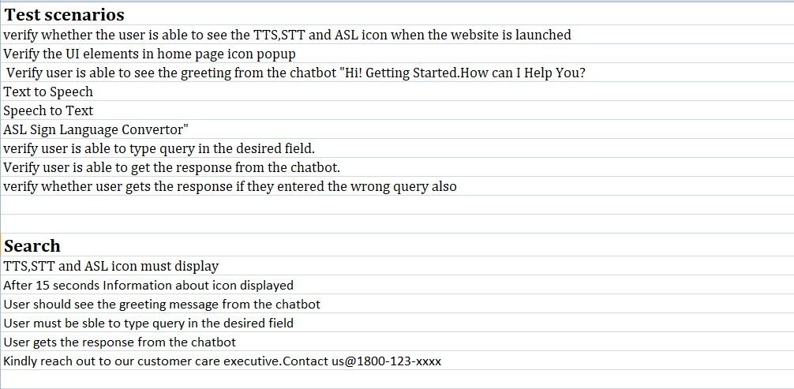

**8. 2 USER ACCEPTANCE TESTING:**

**a) Purpose of Document**

The purpose of this document is to briefly explain the test coverage and open

issues of the AI-based discourse for Banking Industry project at the time of the

release to User Acceptance Testing (UAT).

**b) Defect Analysis**

This report shows the number of resolved or closed bugs at each severity

level, and how they were resolved.

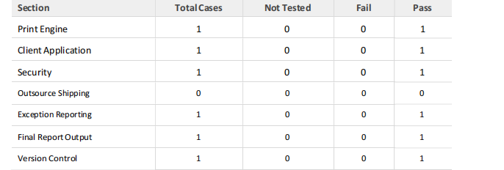

**c) Test Case Analysis**

This report shows the number of test cases that have passed, failed, and

untested.

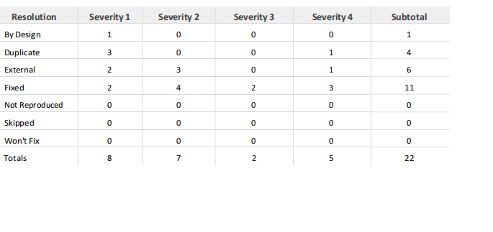

**9. RESULTS:**

**9.1 PERFORMANCE METRICS:**

**Model Performance Testing:**

Project team shall fill the following information in model performance testing template.

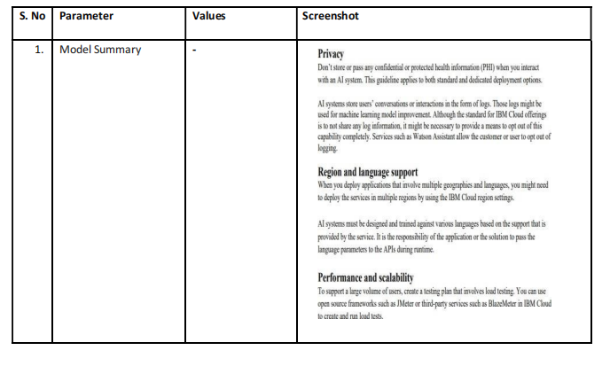

**10. ADVANTAGES AND DISADVANTAGES:**

**ADVANTAGES:**

* Face-to-face conversation allows for increased adaptivity and emotional interpretation
* Get your answer as soon as you ask the question
* Retain personality-sharing and team-building elements of group conversation
* It allows disabled people to enjoy flawless, uninterrupted connectivity using any device of their choice to communicate with others
* It combines multiple communication tools into one interface, communication management program can enable specially able to see in real time which their words are communicated effectively and properly and it is available as of the very moment in the form of text and speech.
* Can communicate easily through this application to the normal people
* Real-time systems are the foundation of advanced technology in various fields like communication, information retrieval, etc.
* These are the fastest available systems and are used in high priority
* The response time of these systems is instant, they don’t lag and provide real-time information or services.
* These systems are able to handle a huge amount of data.
* The performance of such systems is high

**DISADVANTAGES:**

* Users who are not tech savvy often find it challenging to make the most of online communication tools.
* Poor internet connection can cause several delays in messages being sent/received that delays decision-making.
* In the absence of proper communication between the specially abled and normal people there may be chances of misunderstanding or misinterpretation are high..
* Sometimes all these technologies are also not helping the specially abled people to communicate effectively with the normal people
* This makes them to feel that they can’t communicate properly like everyone and it becomes a huge problem in their life
* You can't be sure other people are being honest or that they are who they say they are
* These systems are expensive so these are not available for use to everybody, who are not able to access it with their lifestyle
* Heavy system requirement to use these systems, these systems need special software and hardware resources.
* All real-time systems are online.
* Everyone is not aware of the online resources. Still there are some people who don’t know how to access internet
* System implementation is complex and designing such systems is a difficult task.
* These are the systems that are priority-based and include a sense of real physical time to pass information from one system to another.

**11. CONCLUSION:**

Depending on the type of disability and profile, communicating with others can be a challenge. The same holds true for staying connected to others in a world that’s more and more digitized with the growing importance of social media and our dependence to the Internet. But technology and AI leave no one behind and can be at the service of people with disabilities. A lot of apps use artificial intelligence to favor accessibility. Even people with speech impediments can benefit from AI technology with the app Voiceitt. Thanks to machine learning, Voiceitt can easily understand people with brain injuries or Parkinson’s and whose speech may first seem difficult to apprehend. This app normalizes their speech to create an output of audio or text so that people with speech impediments can still communicate with others and be understood. Of course, AI apps and smart phones aren’t the only way for people with disabilities to communicate and to be connected to others. Web accessibility keeps improving to comply with the Americans with Disabilities Act (ADA) thus providing the same access and services to everybody regardless of their disabilities.

Indeed designing an accessible website can be quite tricky but AI technology turns out to be a game-changer. A site’s design is scanned and analyzed thanks to machine learning. The system forms the base infrastructure for a complete communicational aid system for the deaf and mute. To expand its capabilities, more languages can be easily added by adjusting sensor values. Further, reliance on a dedicated computer system to enable the TTS functionality can be eliminated by adding a portable computer like the Raspberry Pi, which can handle the TTS while retaining portability of such a system. Implemented the object tracking, recognition & classification, and character recognition in offline mode and guarded the app to shrink the size of the app. The main highlight of the project hence came forward, which was being an application that provided a one-stop-shop solution to all the sections of differently-abled people. Integration has provided a seamless User interface/experience for the initial setup. Another point achieved here was no extra hardware; hence, no additional cost to utilize the service. The application still does depend on the camera picture quality for object detection and OCR but is still high enough in confidence level (70%) for most of the cases which were covered.

**12. FUTURE SCOPE**

The system forms the base infrastructure for a complete communicational aid system for the deaf and mute. To expand its capabilities, more languages can be easily added by adjusting sensor values. Further, reliance on a dedicated computer system to enable the TTS functionality can be eliminated by adding a portable computer like the Raspberry Pi, which can handle the TTS while retaining portability of such a system. Higher accuracy could be achieved in the future scope of the implementation through the use of custom models for object detection and text recognition as it could take into account the cases of objects for differently-abled people and work on those only yielding faster and accurate results.

**13. APPENDIX**

**Source code:**

The data set used are publicly available and present in the corresponding link:

https://drive.google.com/file/d/1ITbDvhLwyTTkuUYfNjOKhcIZh7hDgi64/view?usp=sharing

**GIT-HUB and PROJECT DEMO LINK:**

The code is available on Git-hub:

<https://github.com/IBM-EPBL/IBM-Project-20906-1659766229>

Project Demo Link:

<https://youtu.be/NH336jiS4YY>